The Multi County Juvenile Attention System’s Community Corrections Facility is pleased to announce that it has recently completed a re-accreditation audit from the American Correctional Association and finished with 100% compliance on all standards. There are 303 standards (25 mandatory and 277 non mandatory) that the facility has to meet to accomplish accreditation. The MCJAS Community Corrections Facility was officially awarded re-accreditation status following a Panel Hearing in New Orleans, LA, on January 12, 2019. This is the facility’s fourth consecutive re-accreditation finishing with a 100% compliance. Each re-accreditation cycle is for a three-year period, spanning 2 days in which all 307 files are audited, a thorough facility walkthrough of the building and grounds is conducted, and all staff and youth are interviewed. ACA accreditation is one the highest levels of achievement that a correctional facility can obtain.
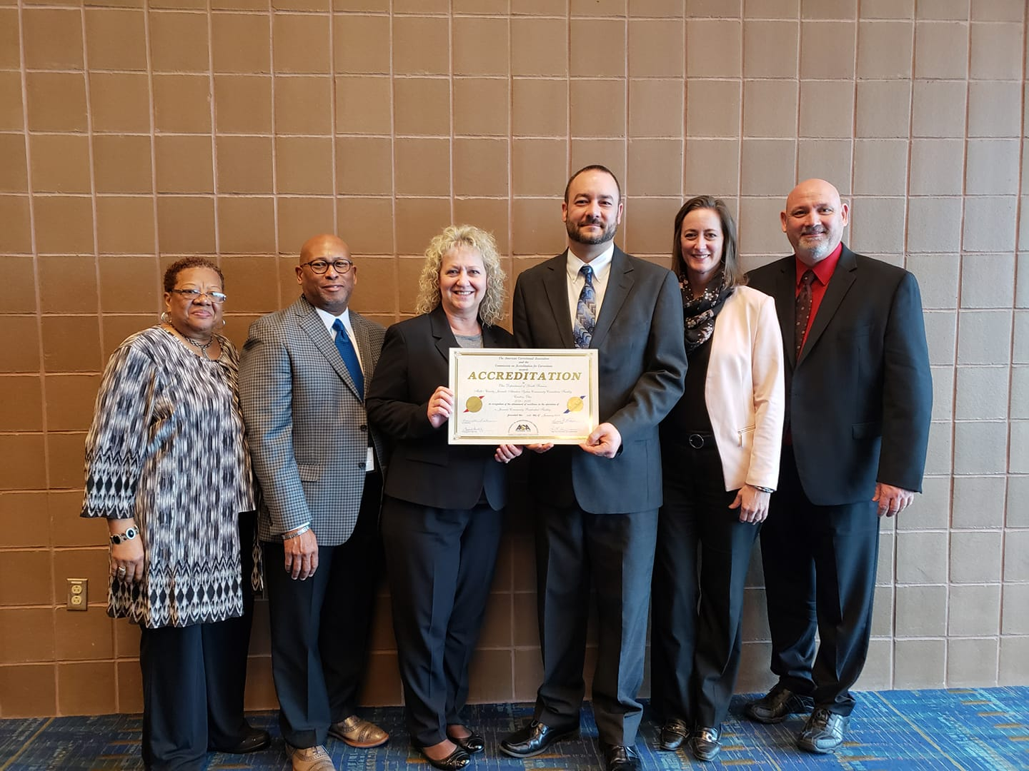

Pictured left to right: ACA Commissioner Inez Tann, recently retired DYS Director Harvey Reed, Stark CCF ACA Coordinator Pamela Byrd, CCF Administrator Bryan W. Hughes, ACA Commissioner Jennifer Gaffney, and ACA Commissioner Rodney Bivens
The Community Corrections Facility is a 24 bed facility serving male youth between the ages of 13 and 18 who have committed a felony and who would have otherwise been sent to the Ohio Department of Youth Services (ODYS). The CCF uses cutting edge assessment instruments to determine the individual needs of youth to better assist in developing a treatment plan. The treatment plan then becomes a map that will lead these young men to gain the skills they need through evidence-based cognitive behavioral programming. The goal is to guide these young men so that they are able to return to their homes to earn, live, and serve successfully in their communities.
Beyond the Community Corrections Facility, the Multi-County Juvenile Attention System (MCJAS) maintains four juvenile attention facilities with one in Stark County, Tuscarawas County, Columbiana County and one in Wayne County. These facilities have also achieved excellent audit ratings from the Ohio Department of Youth Services (ODYS) this past year and have become Prison Rape Elimination Act (PREA) certified.
Another treatment program in MCJAS is the New Philadelphia Girls Group Home licensed by Ohio Department of Jobs and Family Services and is a ten (10) bed facility for female youth. The New Philadelphia Girls Group Home has rated perfect audits for the last several audit periods. This open setting Group Home assists young ladies improve their behavior, works with the to complete high schools education, in some cases gain employment and learn to manage themselves through independent living skills to prepare for adult life.
Finally, the Residential Treatment Center (RTC) is a secure eighteen (18) bed facility with nine bed spaces for boys and nine bed spaces for girls. This facility is secure and education is provided within the facility. The structured student schedule allows the staffing team to work to address a wide variety of behavioral concerns with a battery of assessment instruments being used to create meaningful individualized treatment plans that focus on criminogenic needs. The needs are addressed using a cognitive behavioral curriculum and Trauma & Grief related treatment interventions. Individual, Group and Family Counseling are major components of the RTC program. The staffing team is creative and works to individualize the services provided to each youth according to his/her needs.
Please visit mcjas.org for more information about the Multi-County Juvenile Attention System. If you are interested in a career helping young people, please visit the employment section of our web page or you are welcome to visit us and fill out an application.

